

|  |
| --- |
| DOCSPOT WEB APpLICATION |
| PRAKASH V MERN Stack Developer |
| Web Application Link : https://docsport-users.netlify.app  RSVP TO: Click or Copy Past this Link to Open |
|  | |

LANDING PAGE :



Initial public page with navigation to Login and Register options for users and admins.

REGISTER & LOGIN PAGE :

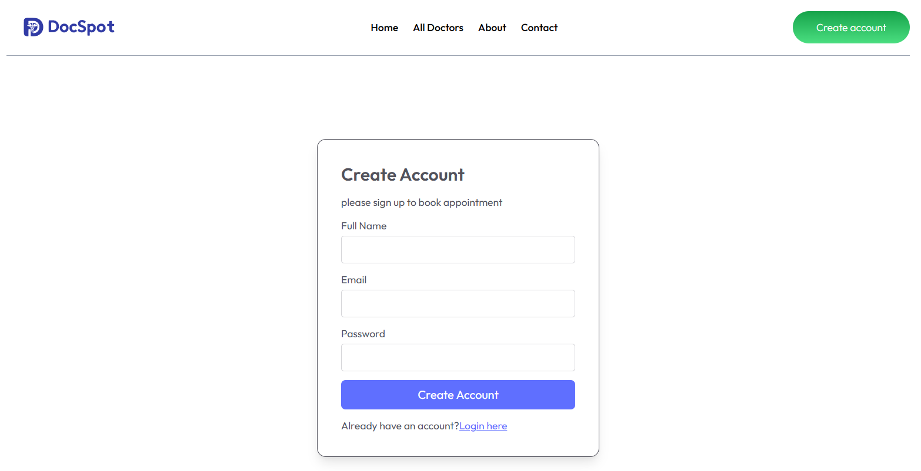

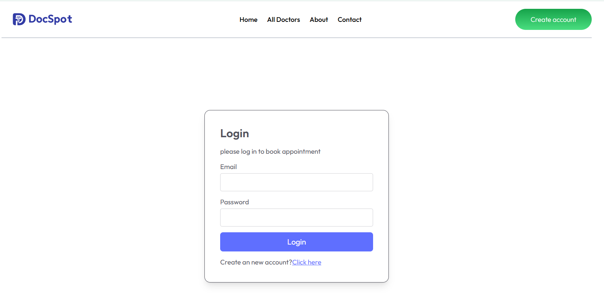

Authenticates users/admins and redirects them to their respective dashboards after verifying credentials.

USER PAGE :



All Doctor Page:

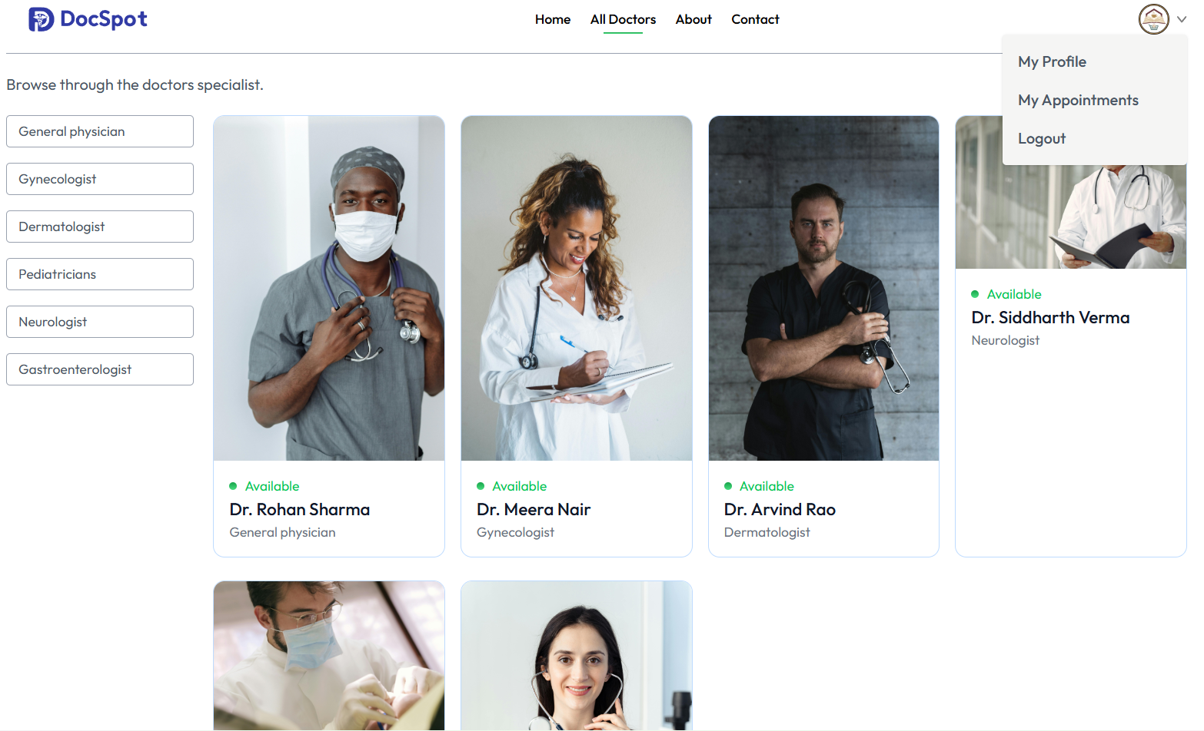

About Page:

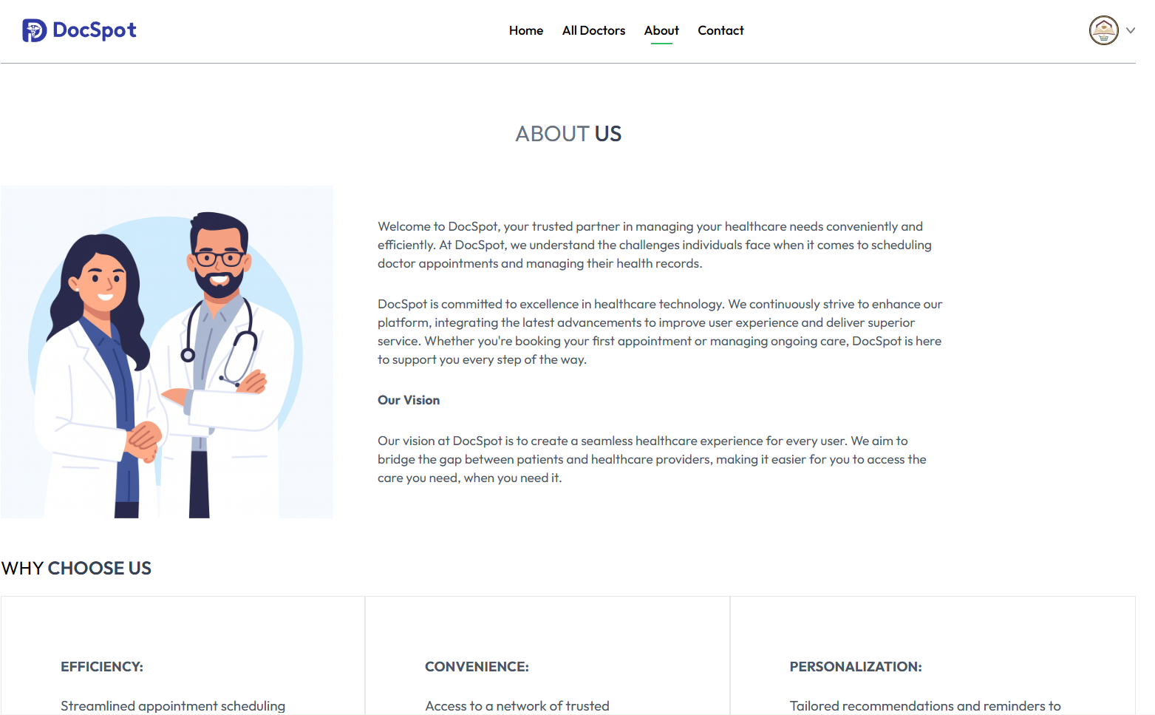

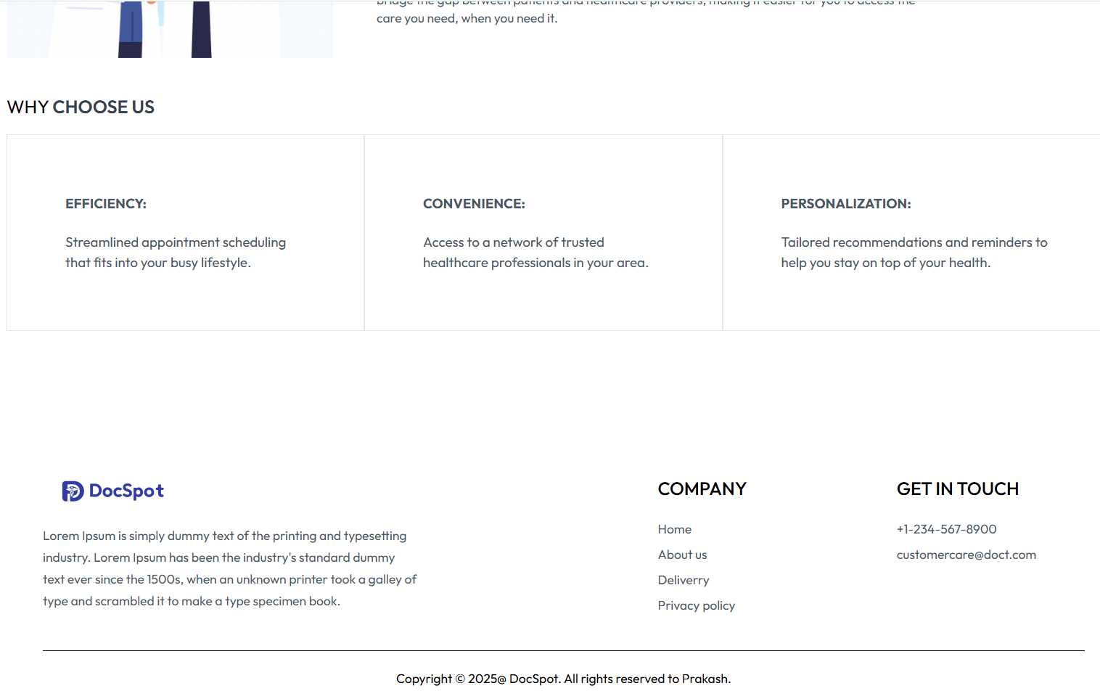

Contact Page:

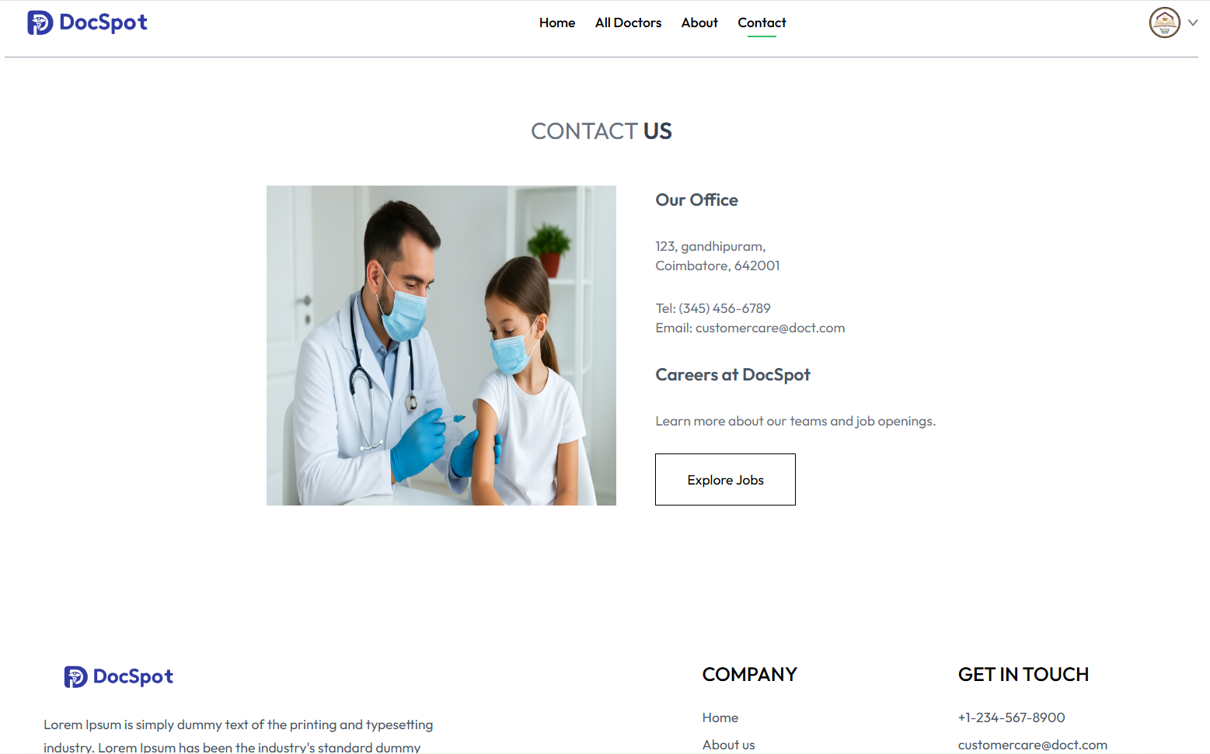

Profile Page:

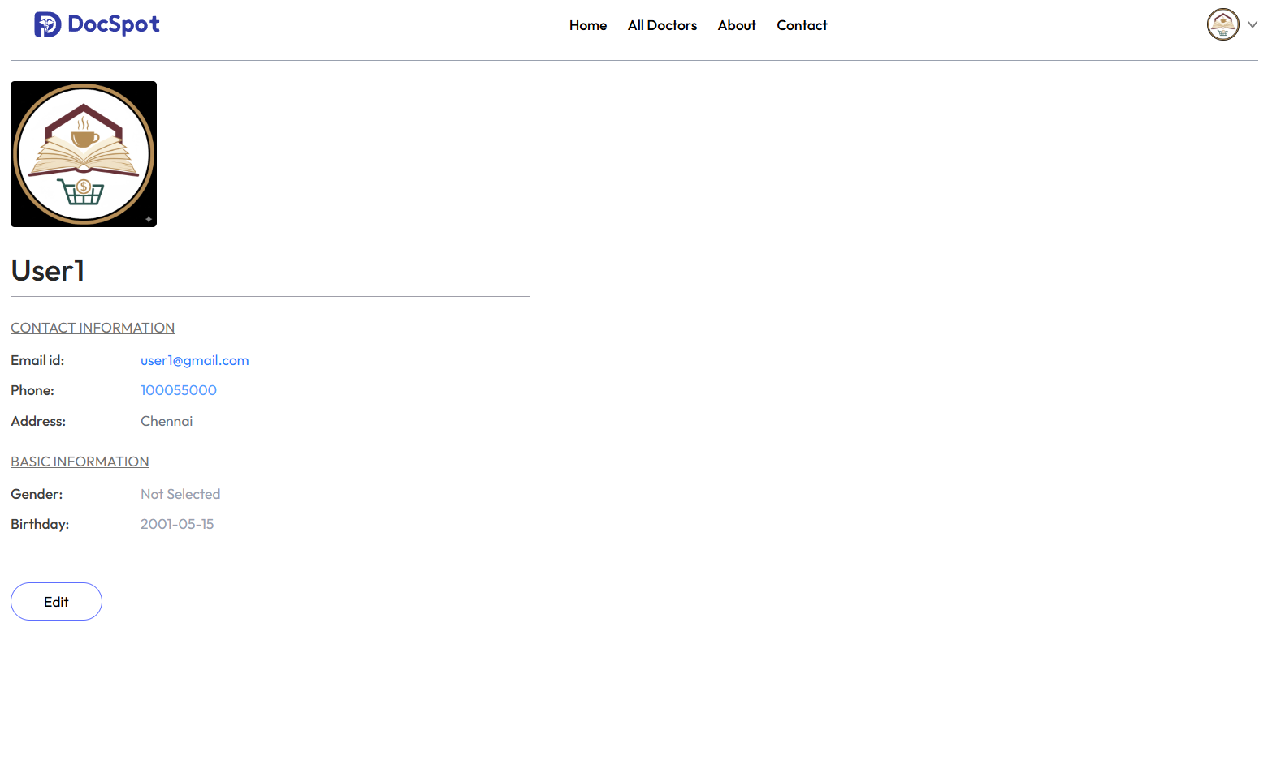

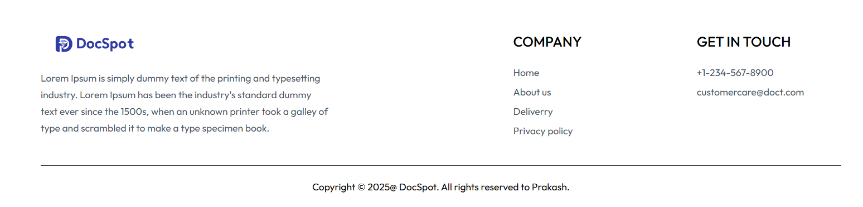

Book Appointment Page:

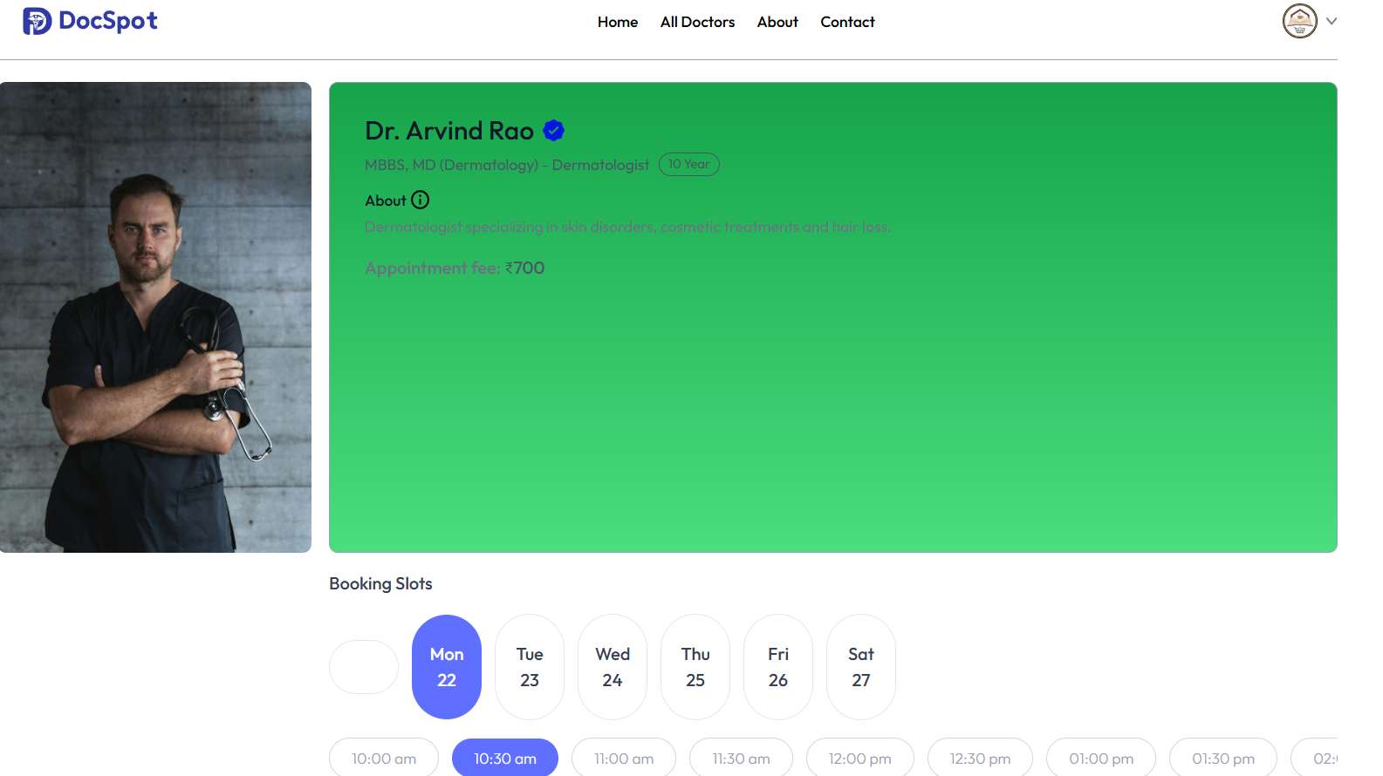

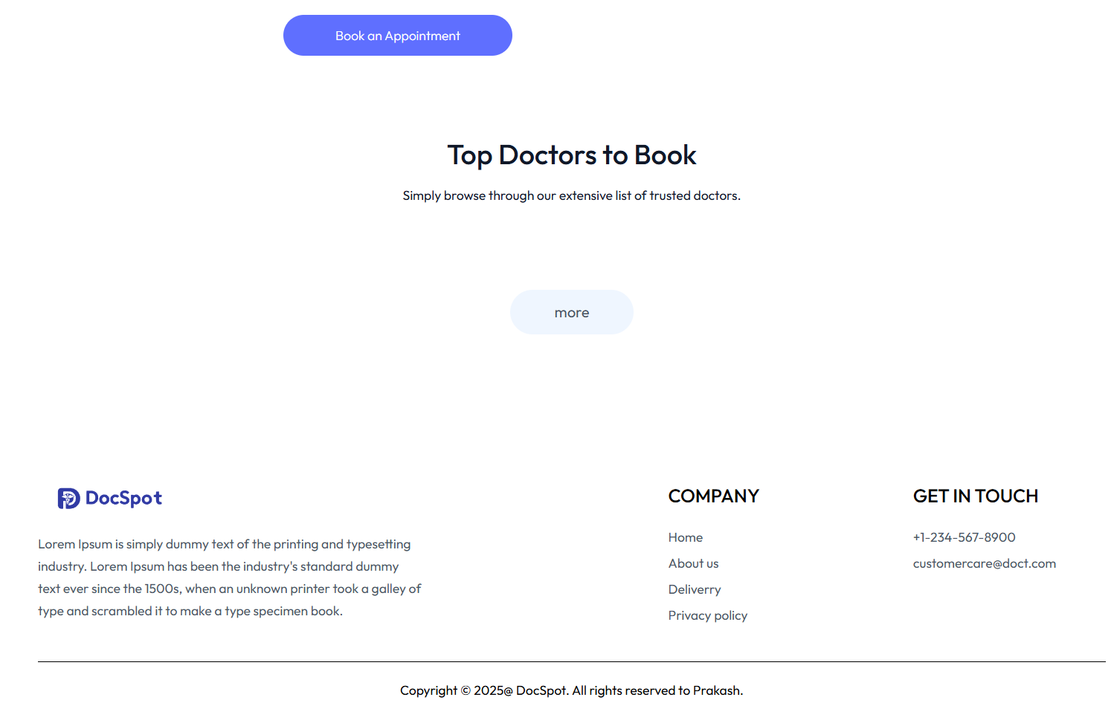

My Appointments:

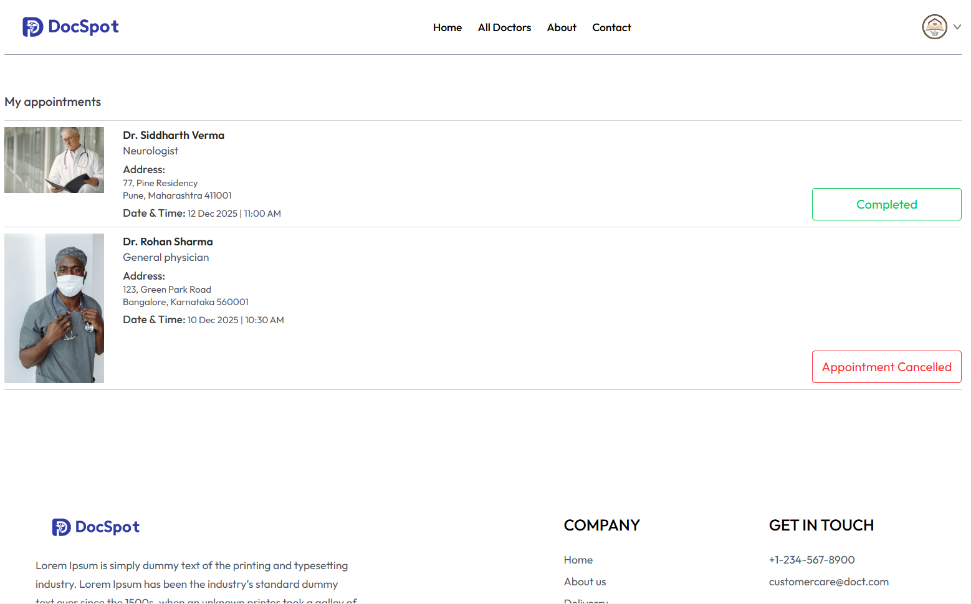

Admin Dashboard:

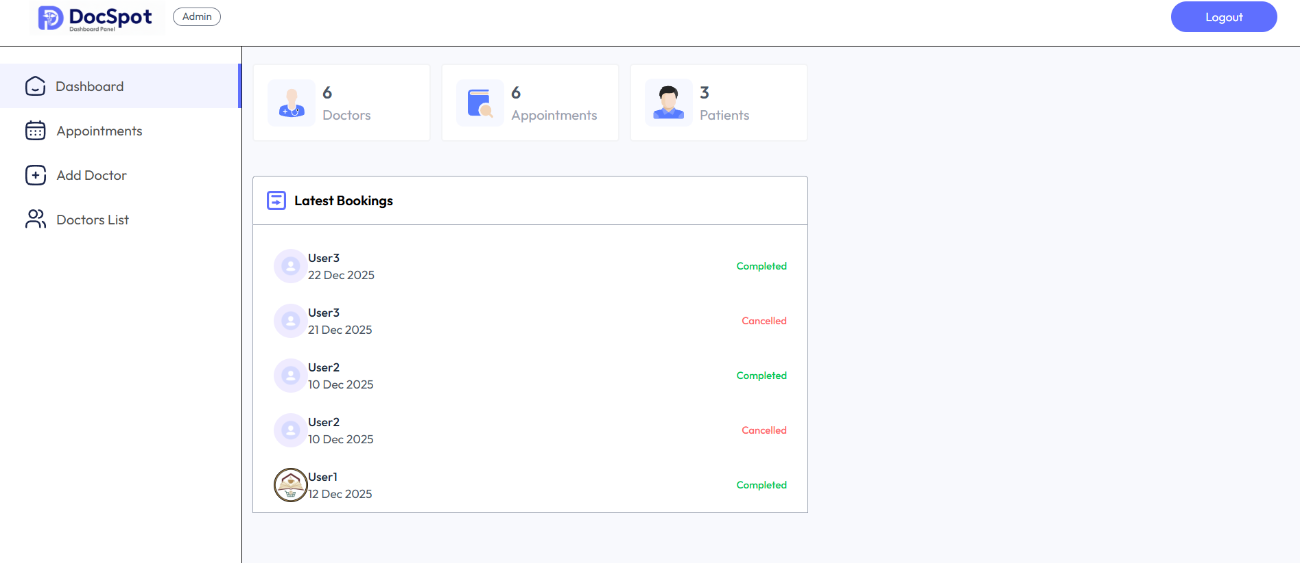

Admin Appointment Page:

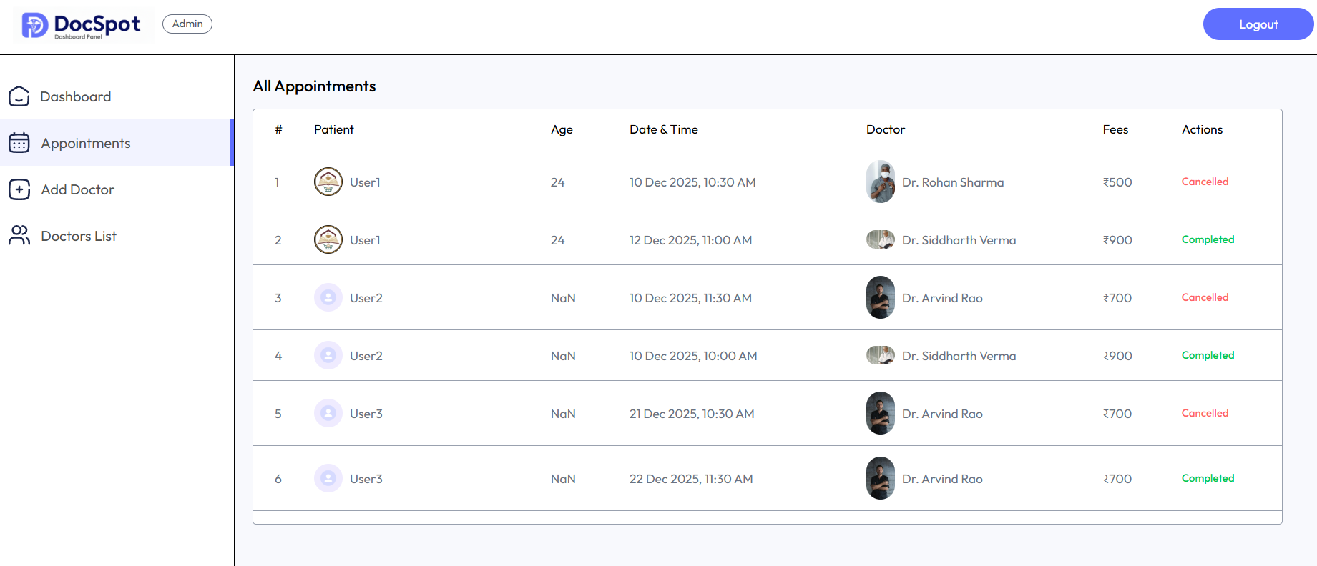

Add Doctor Page:

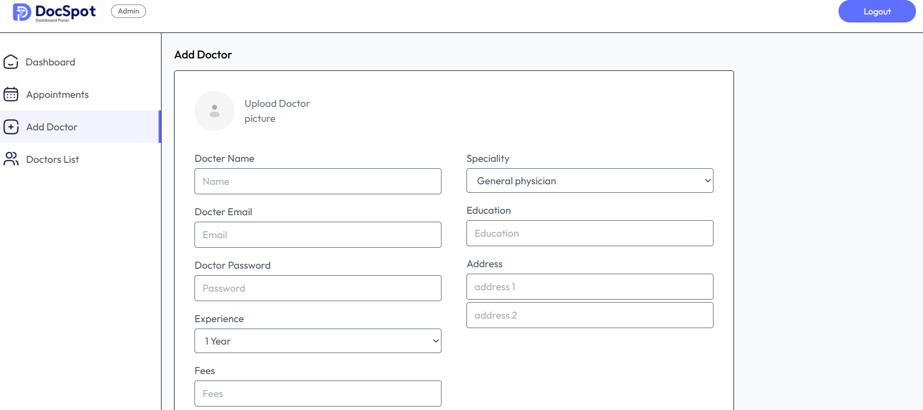

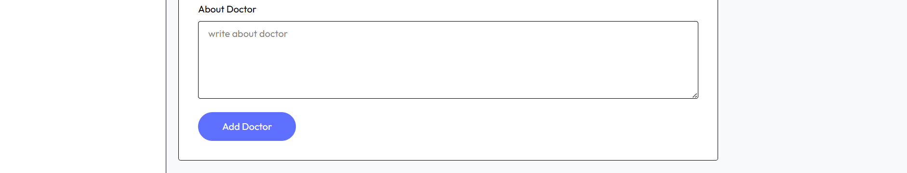

Doctor List Page:

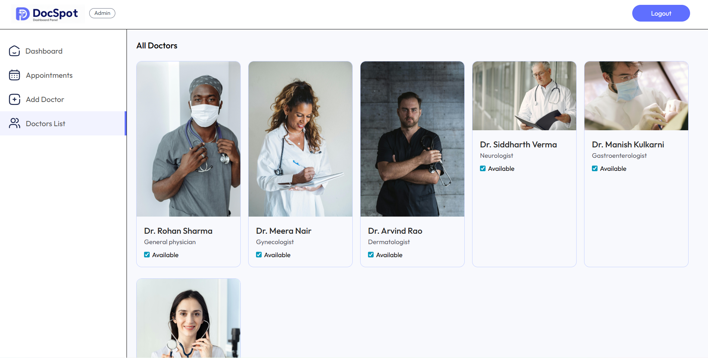

Doctor Login Page:

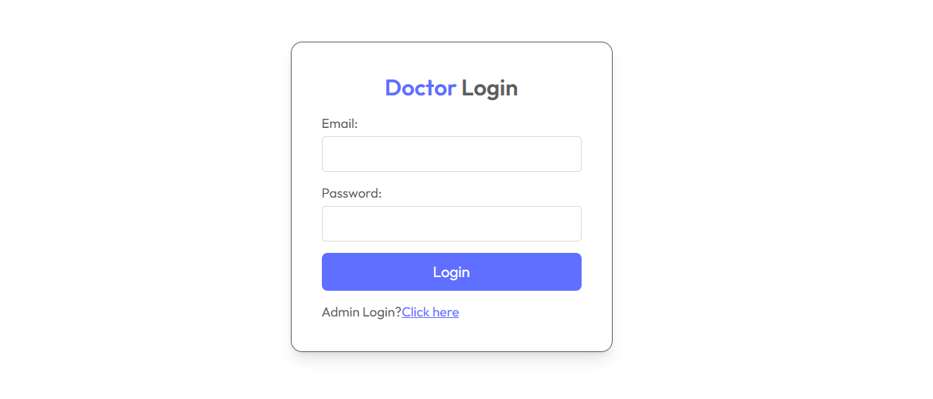

Doctor Dashboard Page:

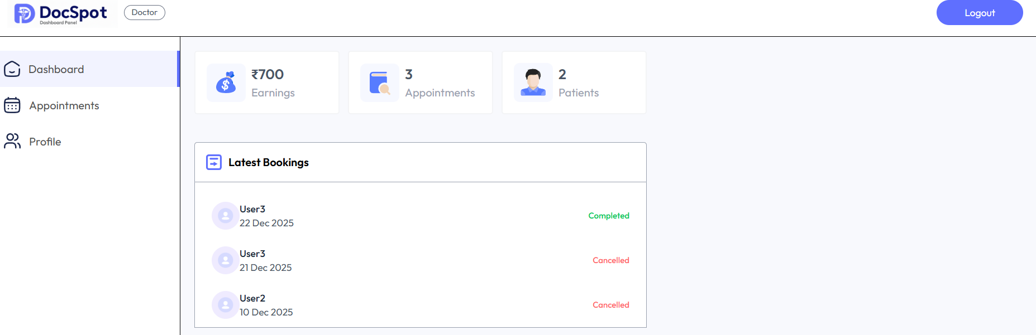

Doctor Appointment Page:

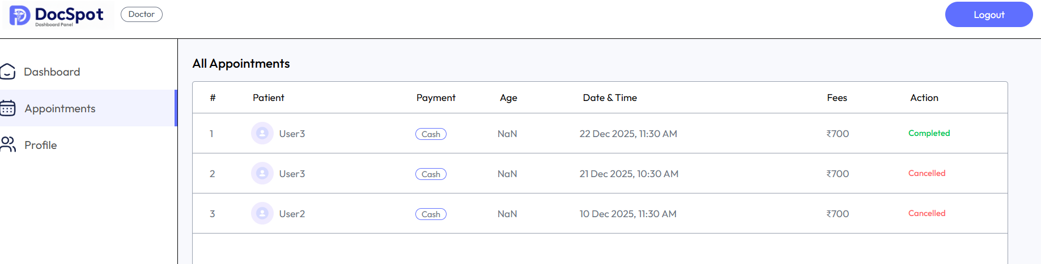

Doctor Profile Page:

